EXPERIMENT 26
ITA0305-Mobile Computing For App Development

26 Design wireframes for a mobile app showcasing data replication techniques. Use Figma to demonstrate the synchronization process.

Aim:
ToDesign a mobile app showcasing data replication techniques using figma

Procedure:
- Open Figma
- Create a new file
- Select the Frames
- Design Visual Elements 5. Make it Interactive
- Add icons on the Frame
- Incorporate Multimedia
- Storyboard Animation
- Review and edit the Prototype
- Save and Share
Design:

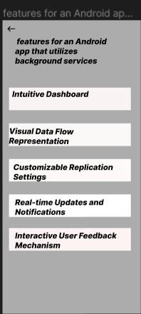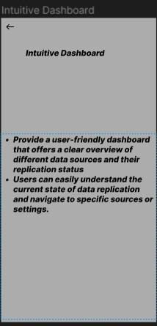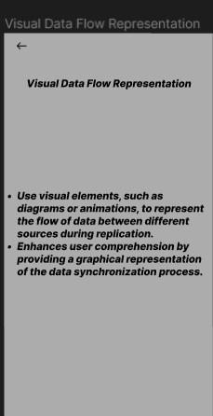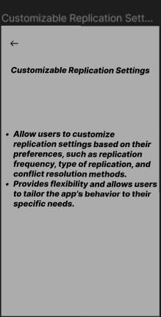

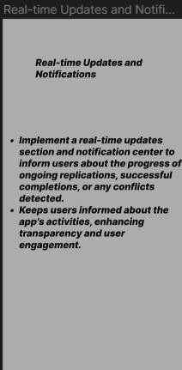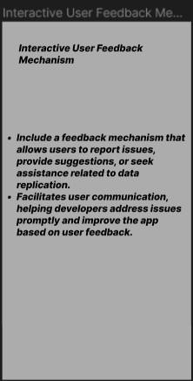

Prototype:
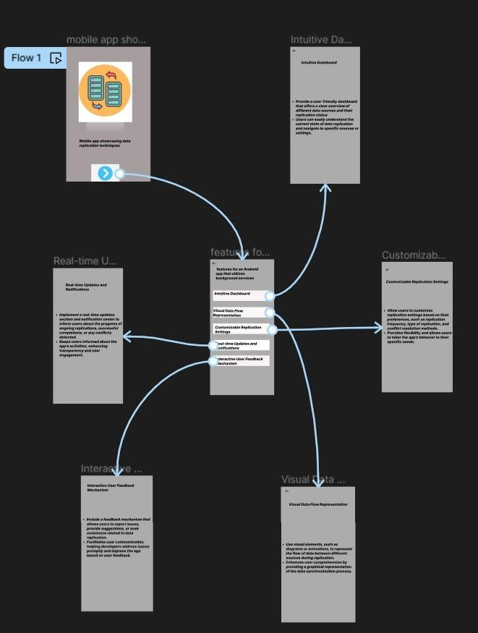
Result: Hencea mobile app showcasing data replication techniques using figma have been created successfully

